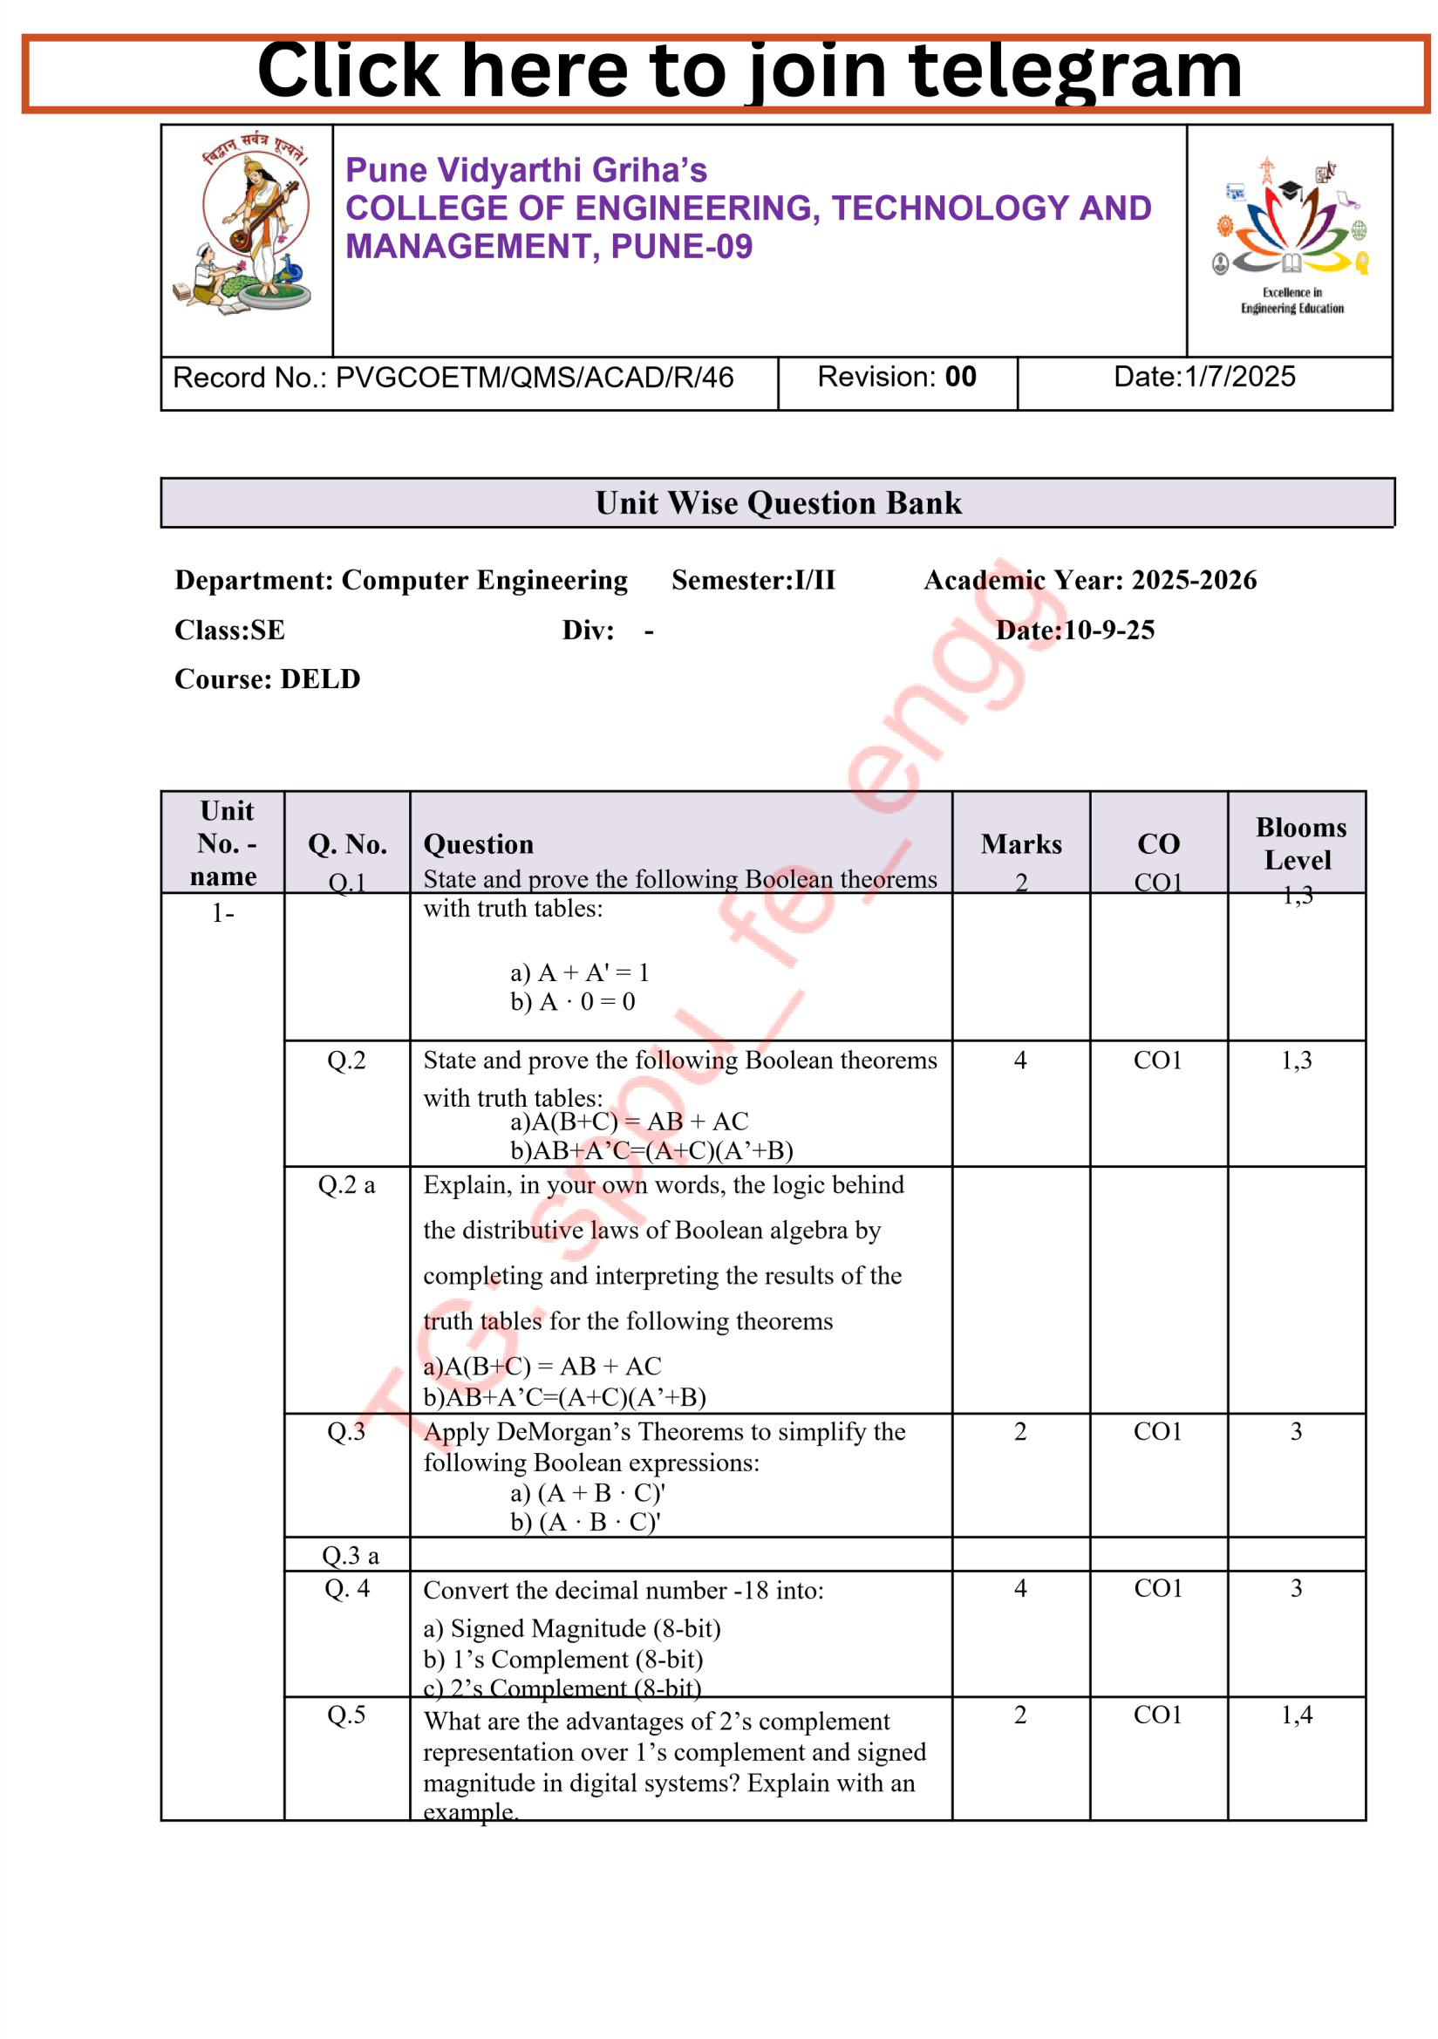




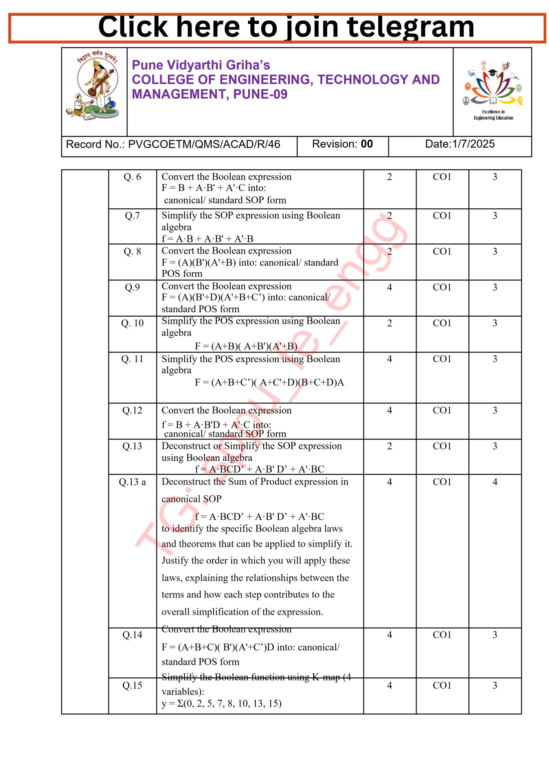

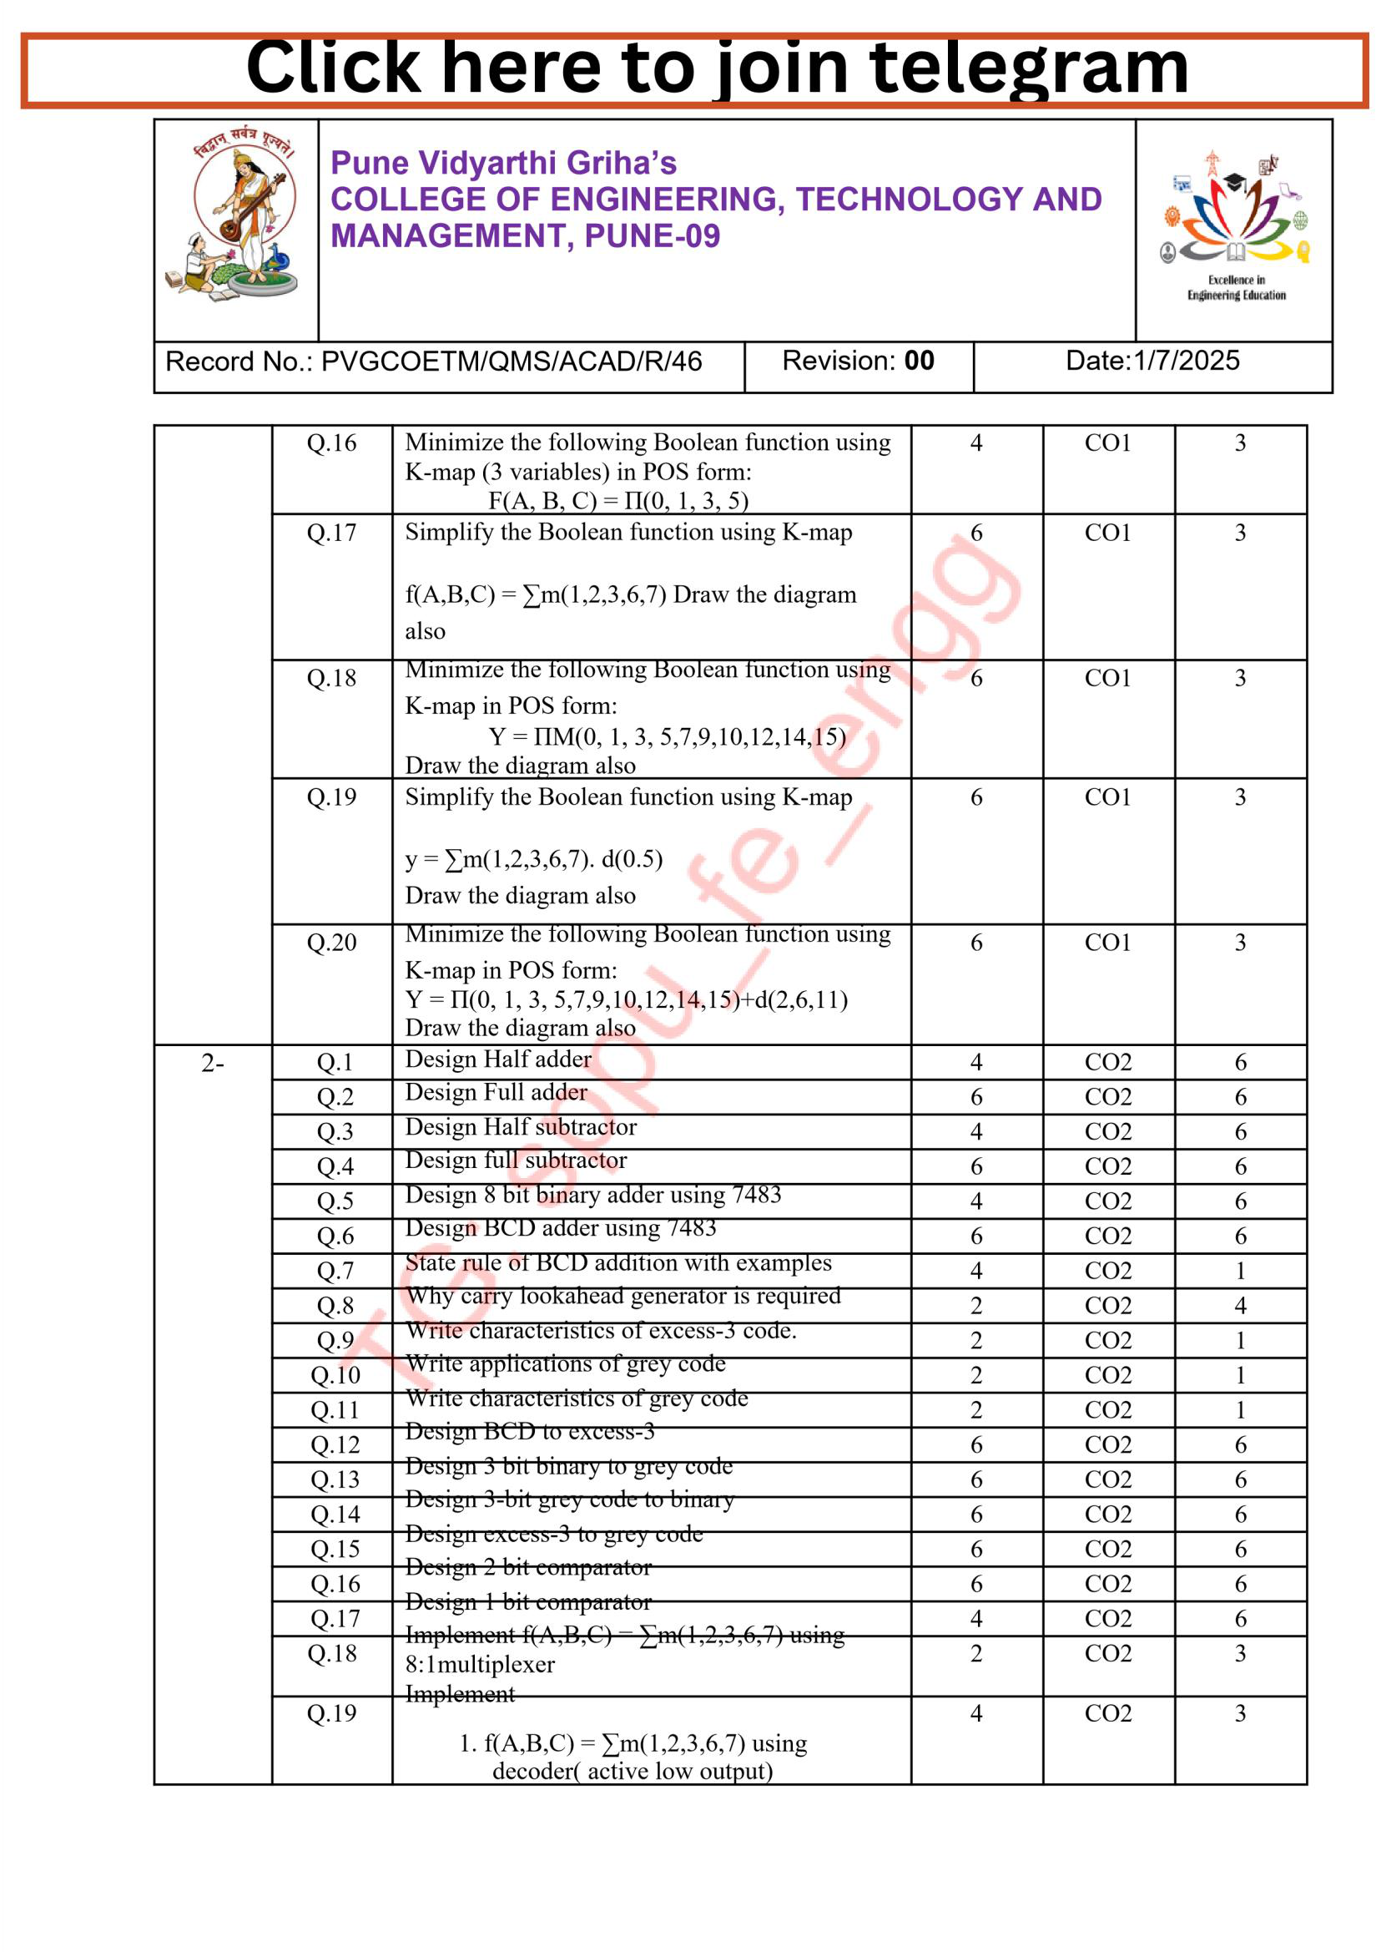

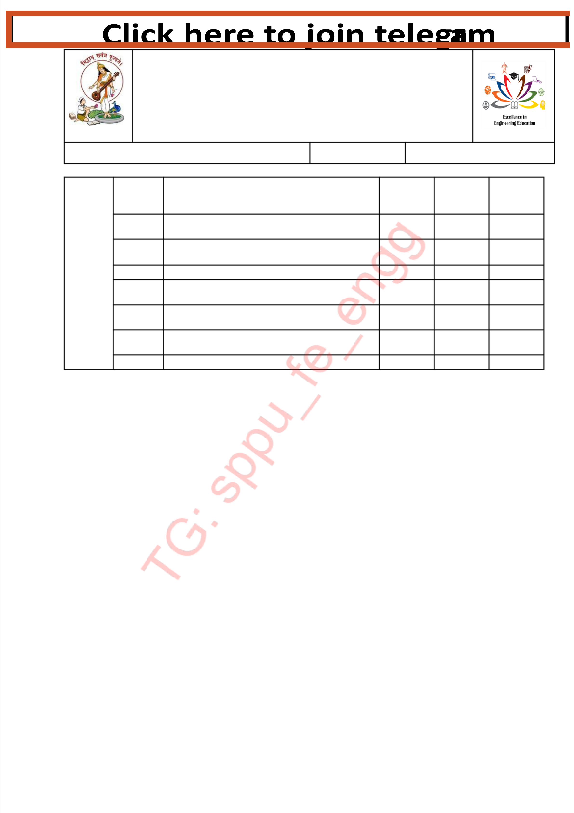
Record No.: PVGCOETM/QMS/ACAD/R/46 | Revision: | 00 | Date:1/7/202 5

Q.2 | g |  |  |  | 3
1 |  |  |  | CO | 3
2 |  |  | 4 |  | 6
2 | 4:1 multiplexe |  | 4 |  | 6
Q.2 3 |  |  |  |  | 3
Q.2 |  |  |  | CO | 3
Q.2 |  |  |  | CO | 3
Q.25 |  |  | 6 | CO2 | 6

